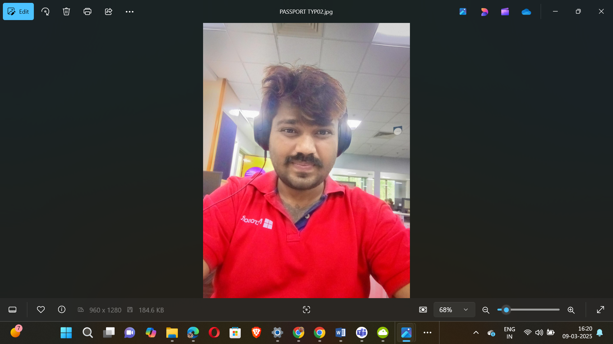

|  |  |
| --- | --- |
|  |  |

🕉️🏇🪓🪈🏹👑👑👑👑👑🤴🦁💿✈️🛸🚀🪩🥏🍥🕺

18+1 JAYA KURUKSHETRA MAHABHARAT SERIES

531

537

541

543

547

551

553

557

559

561

567

571

573

579

583

589

591

593

597

🕺🍥🥏🪩🚀🛸✈️💿🦁🤴👑👑👑👑👑🏹🪈💝🏇🪓🕉️

🕉️🏇🪓🪈🏹👑👑👑👑👑🤴🦁💿✈️🛸🚀🪩🥏🍥🕺

100 – PLATINUM JUBILEE

75 – DIAMOND JUBILEE

50 - GOLDEN JUBILEE

25 – SILVER JUBILEE

Apply 4 x 19 = 76

5

10 – 5 X 2

20 – 5 X 4

40 – 5 X 8

80 – 5 X 16

Apply 5 x 19 = 95

Total 95+76=171 kalalu

SUPREME MAGICAL ✨ SPACE THEATRE PROGRAMMING SHOWSS

🕺🍥🥏🪩🚀🛸✈️💿🦁🤴👑👑👑👑👑🏹🪈💝🏇🪓🕉️



BHAGWAN SRI RAMA SIMHA OMKARAM SRI SRI KING VISNU KALKI SRI KRISNA PARAMATMA SRI SRI KING VISNU SARAT KRISNA PARAMATMA SRI SRI KING ADISIMHA APARAMAHASAHASRA SAHASRASAMASTA SAHASRA SAMASTA APARAMAHASAHASRA BHARGAVA SIMHA TRINETRA APARAMAHASAHASRA SIMHAMAHANKALI ADIPARASAKTI KVADIPARASAKTI ANEKASAHASRA MAHA INFINITY SIMHA SAHASRA AVATARAMULU SRI SRI KING VISNU SUPREME GODS HEADS KING VISNU SUPREME ALFAONKA SAHASRA SAMASTA APARAMAHASAHASRA BHARGAVA SIMHA TRINETRA APARAMAHASAHASRA SIMHAMAHANKALI ADIPARASAKTI KVADIPARASAKTI VAARE SRI SRI KING VISNU KAVERI VEERA BHARAT BHUSHAN MR.KALKIKINGSUPREMEGODSHEADS MEGA KALKI ROBO ALIENS KING SUPREME GODS HEADS KING ALFA SUPREMO 16 KALALU !! 



BHAGWAN KALKIINFINITYADI SESHA SIMHAINFINITYSAREGAMAPADANISAINFINITY SWARALAMAHASWARAMINFINITYKINGSAPTA MAHA VASUKIINFINITY NARAYANAINFINITY MAHABHARATKAMAHAVISNUINFINITYNARAYANA MAHABHARATAMU ALFAROBOALIENSINFINITY SPACE INFINITY WHITESPACE MAHAPOWERFULINFINITY GARUDAMAHAASTRAMU SAMPURNAMAHABHARATASIMHAKALKIINFINITY KAVERI VEER BHARAT BHUSHAN SRI SRI KALKIKINGMAJORKALKIKINGKONGKVK

[S15]16-12-1556[WED] TO

[MON]26-01-3998[S15]

BHAGWANINFINITYRAMASIMHAMAHABHARATBHUSANBHAGWANKALKINARSIMHAINFINITYKINGKALKIBHAGWANKALKIKINGVISNUVARDHANMAHAVISNUSRIMAHAVISNUINFINITY SLIM TO GIGANTIC HOLYSPACEINFINITY KINGKALKIINFINITYMAHAVISNU SRI RAMAINFINITY SRI MAHA VISHNU INFINITY KINGPARAMATMAINFINITY KINGKALKIINFINITY ATIPARAKRAMAINFINITYKINGKALKIKALIMAHANKALIADIPARASAKTIINFINITYHANUMANADIPARASAKTIKINGKALKIKVPARAMATMAINFINITYKVPARAKRAMAINFINITYKVINFINITY KVSRISRI SIMHAIFINITYALFA SIMHA MAHAVISNUM SIMHA MAHAKALKIDHARMASIMHAINFINITYKINGKV INFINITY ATI PARAKRAMA MAHA SIMHA INFINITYSUDARSANA MAHASUDARSANA INFINITYSUDARSANAMAJORCHAKRIADIPARASAKTIINFINITYHANUMANINFINITYKALKIMAHASUDARSANACHAKRAMULU ENNENO-1010

[S15]11-AUG-1919[TH] TO [TH]11-AUG-2929[S15]

BHAGWANKALKI MAHA DHARMA PARAMADHARMAINFINITYSUPREMO SPACES WHITESPACESINFINITY SUPER SIMHA INFINITYPARAMATMA MAHA KALKI SAHASRASIMHAINFINITYVISHNU BHAGWAN KALKIDADAADIPARASAKTIINFINITYHANUMANSAHASRA MAHA VISHNU HANUMANMAHADEV SIMHAINFINITYKALKIINFINITYSRIMAHAVISNUSIMHA KAVERI VEERA TRISULAALA MAHA VISHNU INFINITYSUDARSHANA MAHASIMHA NARSIMHAINFINITY KALKINARSIMHAINFINITY KAVERI KAALA MAHA SUDARSHANA CHARAMU-2994

[S15]07-08-1001[TH] TO

[TH]24-08-3995[S15]

BHAGWAN SIMHA VISHNU INFINITYKALKI MAHADEV KINGALFAINFINITY APARA MAHA SAHASRA MAHA KALKI TRISULA MAHAAYUDHAM-500

[S15]15-08-1962[WED] TO

[TH]10-08-2462[S15]

SUPER POWERFUL KALKI MAHA VISHNU SUPER ROBO SIMHA KALKI MAHA VISHNU SUPER POWERFUL SIMHA SHATABHISHA MAHA VISHNU HANUMAN KALKI MAHA AGNI APARA MAHASAHASRA SAHASRA ! LAKSHALA KOTLA TRISULAALA MAHA TRISULAMULU-2421

[S15]20-08-1567[WED] TO

[TH]11-08-3988[TH]

BHAGWAN SIMHA PARAMATMA HANUMAN KALKI LIONKING LIONGOD SIMHA LION  VISHNU SRI MAHA VISHNU BHAGWAN SRI MAHA VISHNU SUPER SIMHA MAHAVISHNU KING SRIMAHAVISHNUVU SUPER FLUTE  FROM DADDY SIMHA PARAMATMA HANUMAN GAYATRI

15081988065596149IST

BHAGWAN KALKINARSIMHAINFINITYADI SIMHA MAHANKALIKALKI MAHA BHARATMAHAVISHNUADIPARASAKTISUPERMANINFINITYKINGSUPERMANINFINITY SIMHA PARAMATMA KALKIADINARASIMHA VAARE “AYYAVAARU” APARA MAHASAHASRA SIMHA VISHNU MAHAVISHNU SRI MAHA VISHNU SIMHA KALKI MAHA KALKI SIMHA INFINITY KINGINFINITY SRI MAHAVISHNU SRI MAHAVISNUKAVERI SIMHAKALKIBHAGWAN BHRAHMAINFINITY TRINETRAM-1147

[S15]20-08-2852[TUE] TO

[TUE]10-08-3999[S15]

BHAGWAN KALKI MAHAVISHNU TRINETRA CONFIGURATION – INFINITYSIMHARAMAKALKIMAHABHARATASIMHAINFINITY KALKIKINGKONGLIONGODSINFINITYKINGSKALKISIMHAMAHANKALIINFINITYSAHASRAMAHANKALIINFINITYADIPARASAKTIHANUMANKINGETHERINFINITY TRINETRAMU SRI MAHA VISHNU TRINETRA SUPER POWERFUL MAHA SANDARSA MAHAVISHNU MAHA VISHNU TRINETRAMU-500

[S15]20-AUG-2024[TUE] TO [TUE]15-AUG-2524[S15]

SIMHA GHARIMA SUPER SRI MAHA VISHNUVU KALKI BHAGWAN BHARGAVA MAHA SIMHA MAHAVISHNU BHAGWAN SIMHA PARAMATMA HANUMAN KAVERI BHARAT BHUSHAN MAHA SUPER POWERFUL THUNDER STRIKING MAHA SIMHA GADHA ASTRAMU-2070

[S10]15-AUG-1929[TH] TO [TH]5-AUG-3999[S10]

BHAGWAN KALKI VISHNU SRI MAHA VISHNU SIMHA KALKI SRI MAHAVISHNU SIMHA PARAMATMA SIMHA HANUMAN KAVERI VEERA SIMHA BHARATA MAHA VISHNU SRI MAHA VISHNU APARA MAHASAHASRA SUPER POWERFUL SIMHA DHANUNJAYA MAHASIMHA DHANUSSU DHANUNJAYA MAHA DHANUSU-1000

[S15]05-08-2115[MON] TO [TH]29-07-3115[S15]

SIMHA AGNI SUPER POWERFUL KALKI SUPER APOLLOSIMHA MAHAAGNIKHADGAMU SUPER SWORD-2718

[S12]1-08-1278[MON] TO [MON]12-08-3996[S15]

PADMANABHASIMHAASANAM – S12[1276] – S13[3999]-2723

[S12]23-08-1276[SUN] TO [SUN]08-08-3999[S13]

BHAGWANSIMHAKALKIINFINITYSRI SRI KRISNA MAHASANKAMU – 2024

[Z12][S15]25-01-2024[TH] TO [SUN]15-12-2024[S15][Z9]

BHARAT SHIELD – 20024 [1556] TO 3999 DELTA 2443

[Z12][S15]26-01-1556[SUN] TO [MON]06-12-3999[S15][Z9]

APARA MAHA SAHASRA VAIKUNTHA SRI MAHA VISHNU EESHWARA SIMHA VISHNU ADI SIMHA PADMANABHA PRIME KING OPTIMUS SUPER POWERFUL MAHA KALKI LIONKING LIONGOD MAHADEV LION KALKI MAHA VISHNU SUPER PRIME KING OPTIMUS SUPREME GOD HEAD KING KALKI SUPER POWERFUL HANUMAN ROBOT SIMHA KAVERI BHARAT BHUSHAN SUPER MAHA SIMHA SUPER SIMHA POWERFUL SIMHA BACKBONE AGNI JAI SANI MAHA VISHNU KALKI NANDAKAKALKI AGNI MAHA SAHASRA KHADGAMU

1508198806559614973INFINITYHANUMANMAJORVISNUBHAGWANKALKIINFINITYSUPREMEFIRINGINFINITYSPACEDADDYKALKIBHAGWANINFINITYBHARATBHUSHANKAVERIVEERAMAHANANDAKAKHADGAMU-MAJORBHAGWANKALKINARASIMHAINFINITYMAHAVAYUAGNIANTARIKSAADIPARASAKTIINFINITYMAHABHARATKAMAHANANDEESWARAMAHAKHADGAMU INFINITY VARIATIONS SUPREME POWERFUL MEGAKALKIKINGKONGINFINITYSWORDSFORCES KINGINFINITYSIMHAINFINITYMAHABHARATKAMAHAVISNUSRIMAHAVISNUINFINITYKALKIINFINITYADIPARASAKTISUPERMANTALWAR KINGINFINITYSULTAN MEGAKINGKALKIKINGKONGFIRE INFINITY AGNI MAHAGNI SUPREME SUPREMO INFINITY WHITESPACE HANUMANSWORDS

APARA MAHA SAHASRA PARAMASIMHA PRATYANGIRA SRI MAHA VISHNU INFINITYNARSIMHA KALKINARSIMHA SAHASRASIMHAMAHANKALIADIPARASAKTIMANINFINITY KINGPARAMATMA INFINITYMAHA SIMHAASANA VAHANAMU MAJOR KALKI KING NARSIMHA NARSIMHA INFINITY SUPREME WAGON INFINITY LIONKINGS LIONKINGINFINITY WAGONS INFNITYSPACEJETS KINGVOYAGOSPACETRAVELLINGINFINITYHANUMANVAHANAMU-3496

[S15]04-08-502[SUN] TO

[FRI]21-08-3998[S15]

